Council for IWU Women Hosting Annual Summit
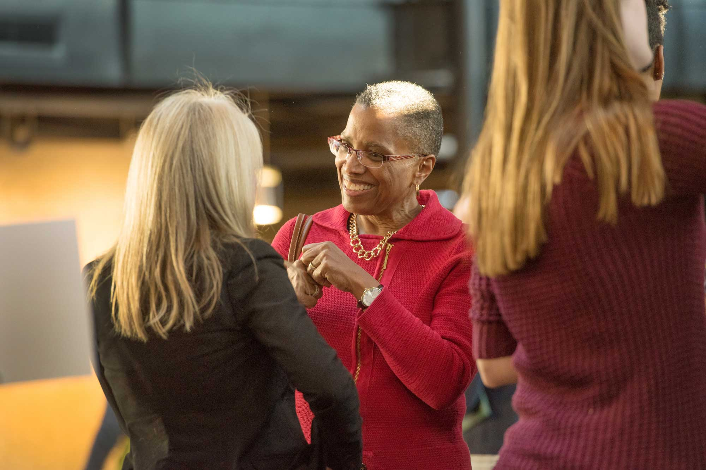
Feb. 12, 2016

BLOOMINGTON, Ill.— For the past 10 years, Illinois
Wesleyan alumnae have been offering guidance and
mentorship to current female students through the
Council for IWU Women. The Council’s signature event is
its annual summit, set this year for Feb. 26-27 centered
on the theme “At the Table”, and open to all IWU female
faculty, staff and students.

Keynote speaker for Friday’s luncheon is Karen Zander,
RN, MS, CMAC, FAAN. A 1970 graduate of IWU with a
Bachelor of Science in Nursing, Zander is president and
CEO of The Center for Case Management, a
Massachusetts-based, clinician-owned company providing
case management leadership to the healthcare industry.
Leah Merrifield '78, who was the keynote speaker at the 2015
summit, mingles with students and fellow alumni.

Zander’s address at 11:45 a.m. in the Young Main Lounge
is entitled “Finding Your Strength.”

Other summit events include the first “She Speaks,” an event powered by the PechaKucha presentation style. “She Speaks
begins at 6 p.m. Friday at the Hansen Student Center. More than 10 students, alumnae and faculty are scheduled to present
their stories in fast-paced presentations of no more than 20 slides each. Practice interviews, career networking events and
sessions, and Saturday’s luncheon with the announcement of scholarship recipients are among the summit’s other events.

The Council for IWU Women is a group of over 80 alumnae and friends from throughout the United States and one member
currently living in Thailand. Each year a contingent of council members return to campus to offer their talents and resources
to support the personal and professional development of the women of IWU. The event provides the opportunity for students
to connect with women who are leaders in their professions and communities and who exemplify mentorship for students.

All events are free, as the meals and all summit activities are fully funded by Council for IWU Women members. Registration is required, however, by Feb. 22. Laine Twanow ’04 and Abby Sullivan ’08 are serving as summit co-chairs for 2016. Carole Liske
’77 is president of the Council for IWU Women.

